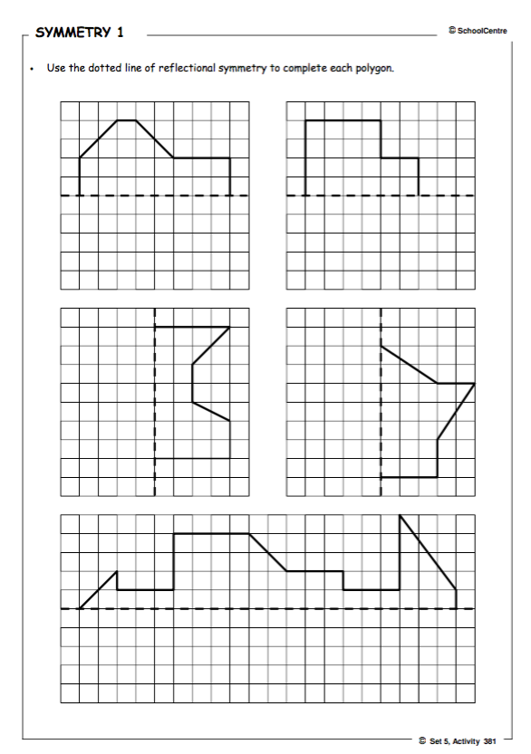Macintosh HD:Users:localadmin:Desktop:382_Symmetry_2.pdf