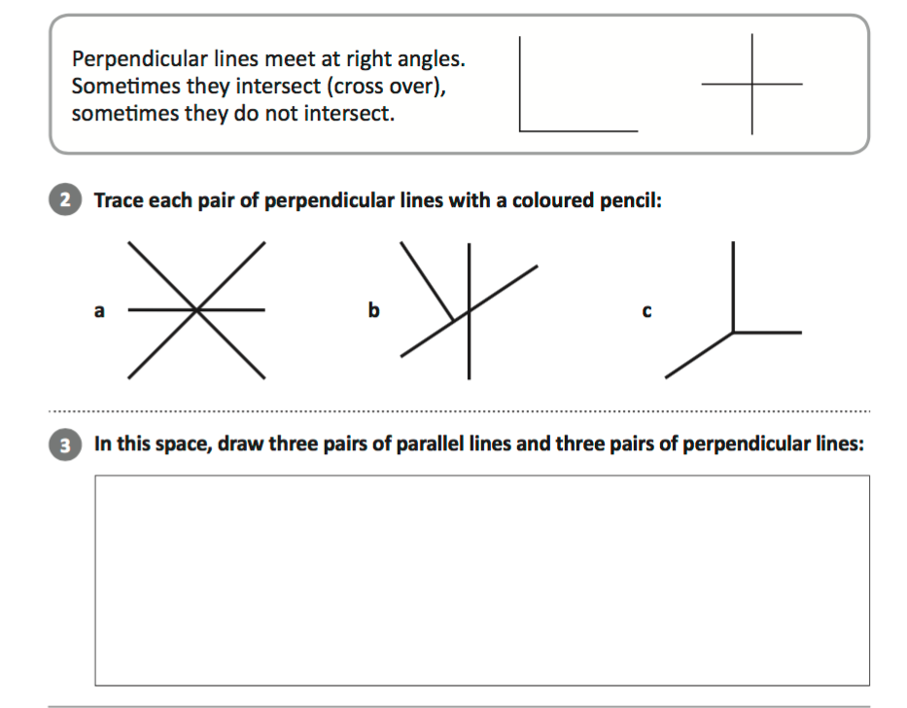
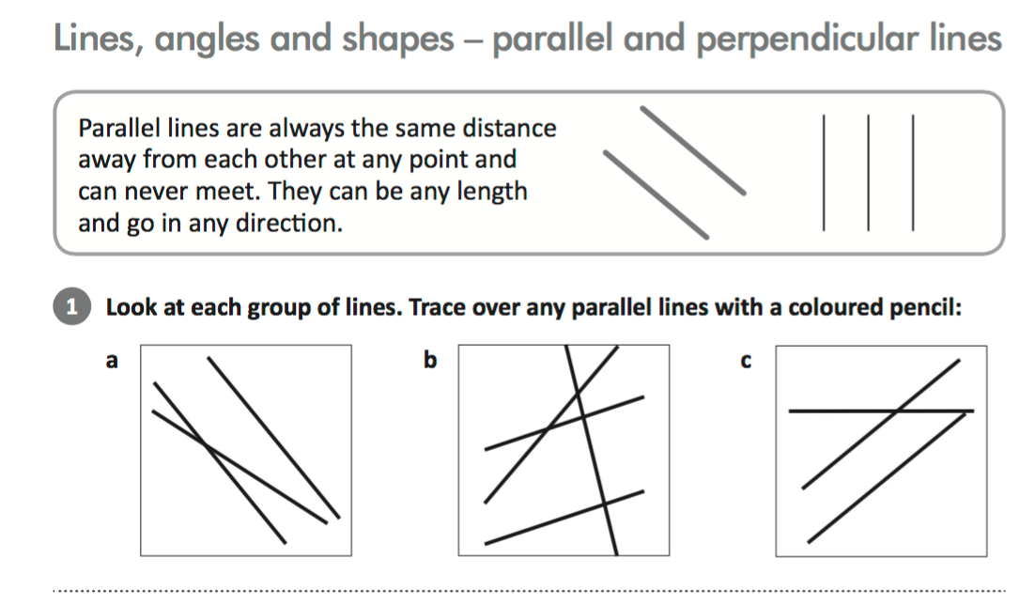
Extension: Draw a 2D shape that has parallel lines and perpendicular lines:

